Biological Terms Glossary

Actinopterygii: The ray-finned fishes. All tetraodontiformes are ray-finned, meaning that the bones in their fins extend into the flesh, creating “rays” which support the fin tissue.

Benthic: The lowest region of any body of water, containing substrate and bottom dwelling animals. There is technically a distinction between invertebrates + microflora and fishes of the benthic zone, but that is beyond the scope of this class.

Binomial Nomenclature: The two-part, scientific name of a species. The first part names its genus, and the second elaborates its species. For example, there are three species in the genus Molidae, given by the binomial nomenclatures Mola mola, Mola tecta, and Mola alexandrini.

Clavus: In ocean sunfish, the caudal fin (rearmost fin) is missing and instead replaced by a rudder known as the clavus, formed by the convergence of its dorsal and anal fins.

Dentary: The lower jaw bone.

Fins: Fish typically have 6 types of fins. The pectoral fins are located on the sides of the body. The pelvic fins are located on the bottom of the fish, closer to the mouth than the anal fin, also on the bottom. Dorsal fins are located on the top of the fish, and their number varies by species. The caudal fin is the fish’s tail located closest to its back.

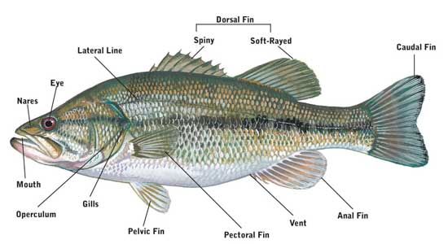

Genus: The second most specific taxonomic classification, above species. Plural: genera.

Ichthyology: The scientific study of fish.

Lateral Line: A system of sensory organs in fish which form a “line” down the body and are used to detect water motion and pressure changes.

Morphology: The physical feature of an organism and the study of how organisms’ physical features relate them to one another.

Pelagic: An adjective describing the waters of the open ocean. E.g., while several tetraodontiform species are reef dwellers, the Molidae occupy the pelagic zone.

Plectognathii: A synonymous term with Tetraodontiforme.

Premaxilla: The upper jaw bone(s).

Taxonomy: Classification of organisms based on the idea of tracing common ancestors morphologically and genetically.

